* **Task 1 - A:**

You survey households in your area to find the average rent they are paying. Find the standard deviation from the following data:

$1550, $1700, $900, $850, $1000, $950.

* **Solution 1 -**
* Step 1 – Calculation of Mean – (x1+x2+x3+x4+x5+x6)/(n-1)

(1550+1700+900+850+1000+950) / 6 = **1158.33**

* Step 2 – Calculation of Variance –

|  |  |  |
| --- | --- | --- |
| 1550 | 392 | 153403 |
| 1700 | 542 | 293403 |
| 900 | -258 | 66736 |
| 850 | -308 | 95069 |
| 1000 | -158 | 25069 |
| 950 | -208 | 43403 |
| **1158.33** |  | **677083.3** |

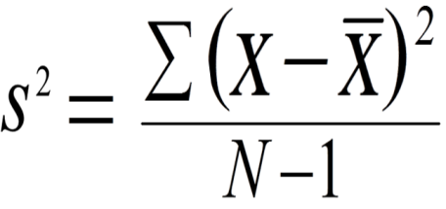

Variance –

677083.3/(6-1) = **135416.7**

* Step 3 – Calculation of Standard Deviation –

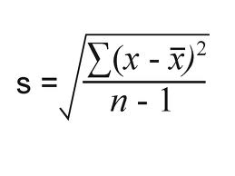

√135416.7= 367.99  
 Therefore, Standard Deviation is **367.99**

* **Task 1 - B:**

Find the variance for the following set of data representing trees in California (heights in feet):

3, 21, 98, 203, 17, 9

* **Solution 2 -**
* Step 1 – Calculation of Mean – (x1+x2+x3+x4+x5+x6)/n

(3+21+98+203+17+9) / 6 = **58.5**

* Step 2 – Calculation of Variance –

|  |  |  |
| --- | --- | --- |
| 3 | -55.5 | 3080.25 |
| 21 | -37.5 | 1406.25 |
| 98 | 39.5 | 1560.25 |
| 203 | 144.5 | 20880.25 |
| 17 | -41.5 | 1722.25 |
| 9 | -49.5 | 2450.25 |
| **58.5** |  | **31099.5** |



Variance –

31099.5/(6-1) = **6219.9**

Therefore, Variance is **6219.9**

* **Task 1 - C:**

In a class on 100 students, 80 students passed in all subjects, 10 failed in one subject, 7 failed in two subjects and 3 failed in three subjects. Find the probability distribution of the variable for number of subjects a student from the given class has failed in.

* **Solution 3 –**
* The probability of failing in 0 subjects, P(X=0) =80/100 =0.8  
  The probability of failing in 1 subjects, P(X=1) =10/100 = 0.1  
  The probability of failing in 2 subjects, P(X=2) =7/100 = 0.07  
  The probability of failing in 3 subjects, P(X=3) = 3/100 = 0.03

The probability distribution can be shown as:

|  |  |  |  |  |
| --- | --- | --- | --- | --- |
| X | 0 | 1 | 2 | 3 |
| P(X) | 0.8 | 0.1 | 0.07 | 0.03 |

**TASK 2 – A-**

A test is conducted which is consisting of 20 MCQs (multiple choices questions) with every MCQ having its four options out of which only one is correct. Determine the probability that a person undertaking that test has answered exactly 5 questions wrong.

**Solution –**

Here, n = 20, n - k = 5, k = 20 - 5 = 15

Here the probability of success = probability of giving a right answer = s = 1/4

Hence, the probability of failure = probability of giving a wrong answer = 1 - s

= 1 – 1/4 = 3/4

When we substitute these values in the formula for Binomial distribution we get,

So, P (exactly 5 out of 20 answers incorrect) = C (20, 5) * (1/4) ^ 15 * (3/4) ^ 5

→ P (5 out of 20) = (20∗19∗18∗17∗16) / (5∗4∗3∗2∗1) * (1/4) ^ 15 * (3/4) ^ 5

= 0.0000034 (approx)

Thus, the required probability is **0.0000034** approximately.

**TASK 2 –B-**

A die marked A to E is rolled 50 times. Find the probability of getting a “D” exactly 5 times.

**Solution –**

Here, n = 50, k = 5, n - k = 45.

The probability of success = probability of getting a “D”= s = 1/5

Hence, the probability of failure = probability of not getting a “D” = 1 - s = **4/5**.

**TASK 2 –C-**

Two balls are drawn at random in succession without replacement from an urn containing 4 red balls and 6 black balls. Find the probabilities of all the possible outcomes.

**Solution –**

First determine the probabilities of the events.

**Events Probability**

RR = (4/10)(3/9) = 2/15

RB = (4/10)(6/9) = 4/15

BR = (6/10)(4/9) = 4/15

BB = (6/10)(5/9) = 1/3

The probability of 0 blue balls (RR) is 2/15

The probability of 1 blue ball is (RB or BR) is 4/15+4/15 = 8/15

The probability of 2 blue balls (BB) is 1/3

So, the probability distribution is: Z p(Z)

--------

0 = **2/15**

1 = **8/15**

2 = **1/3**